Please execute below package manger command or execute script to generate database.

Need to change database name in appsettings.json file.

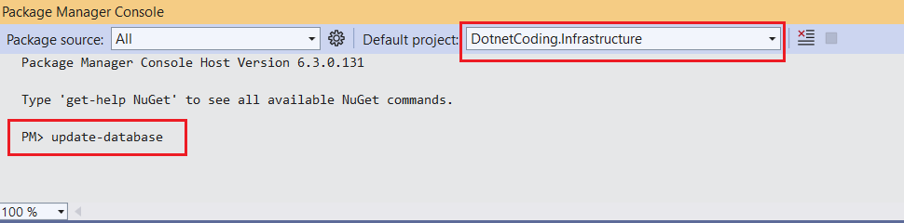

Here is some payload to create/update product.

* Create Product

https://localhost:7160/api/Products/Create

{

"name": "iPhone 15",

"description": "iPhone 15",

"price": 1000

}

* update Product

https://localhost:7160/api/Products/Update

{

"productId": 1,

"name": "iPhone 15",

"description": "iPhone 15",

"price": 2000,

}

* get product

https://localhost:7160/api/Products/List

{

"productName": "samsung"

}

* get List ofproduct

https://localhost:7160/api/Products/List

{

}